PNT2022TMID32730

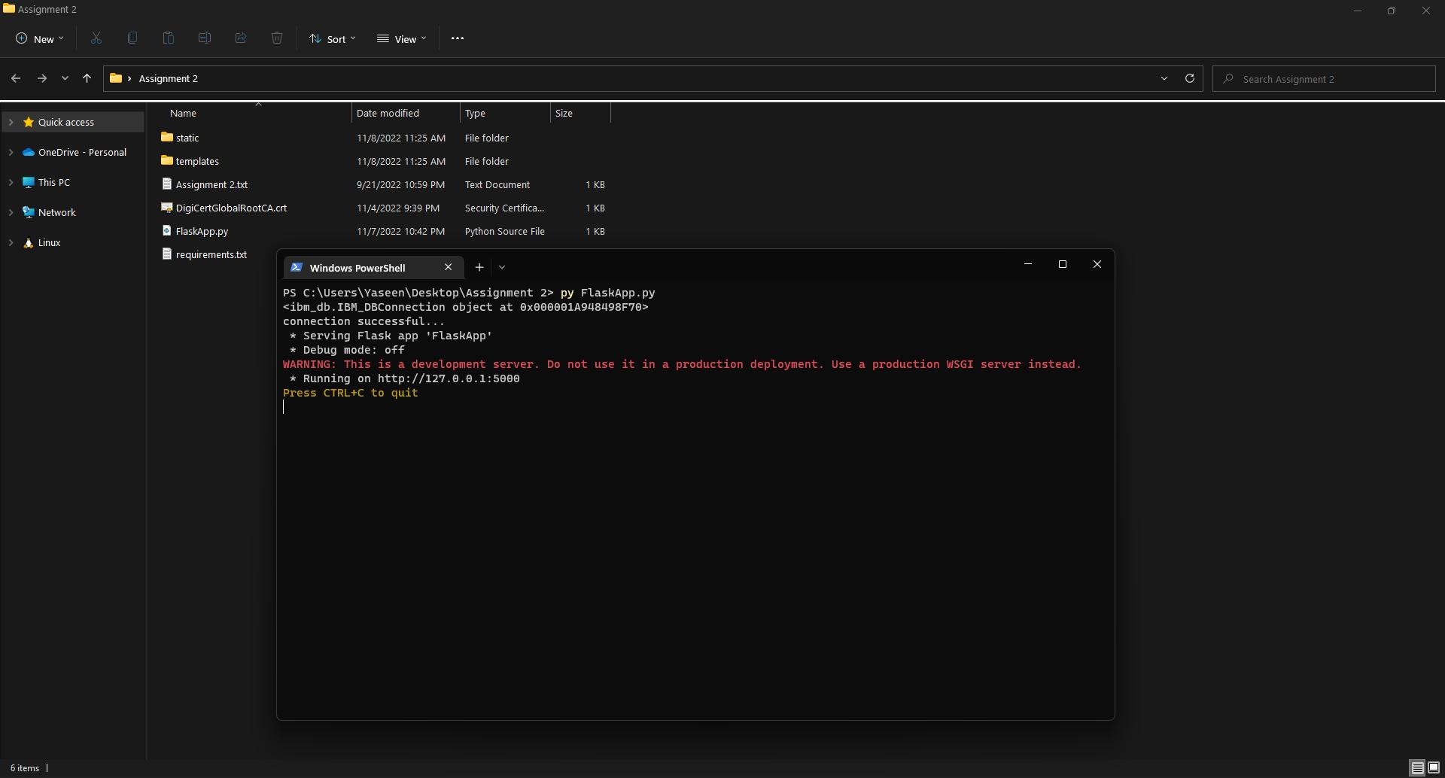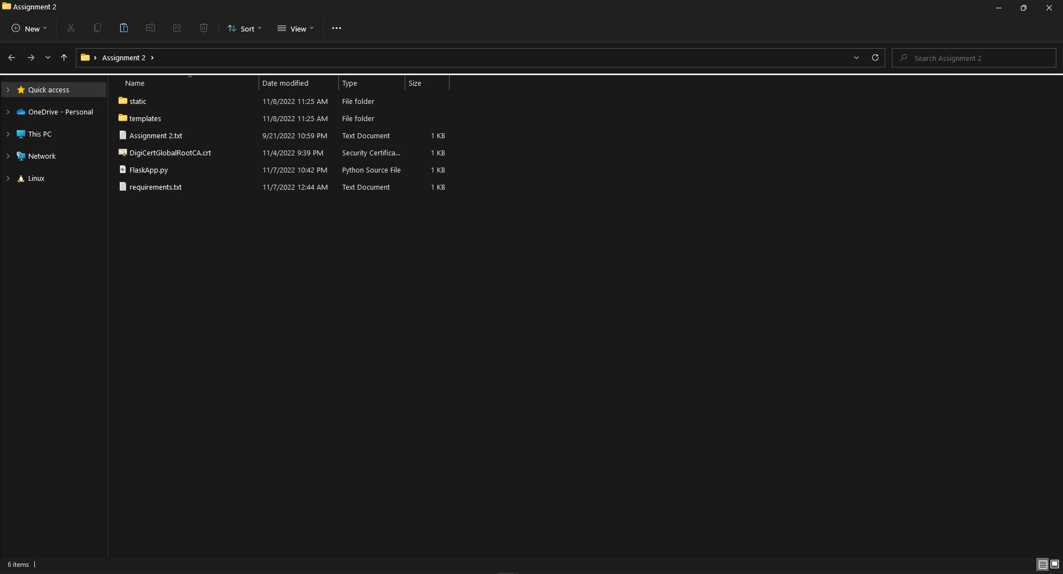

**Flask Project:**

Project – Inventory Management System for Retailers

**Project Name**

**Setting Up Application Environment**

**Team ID**

31October 2022

**Date**

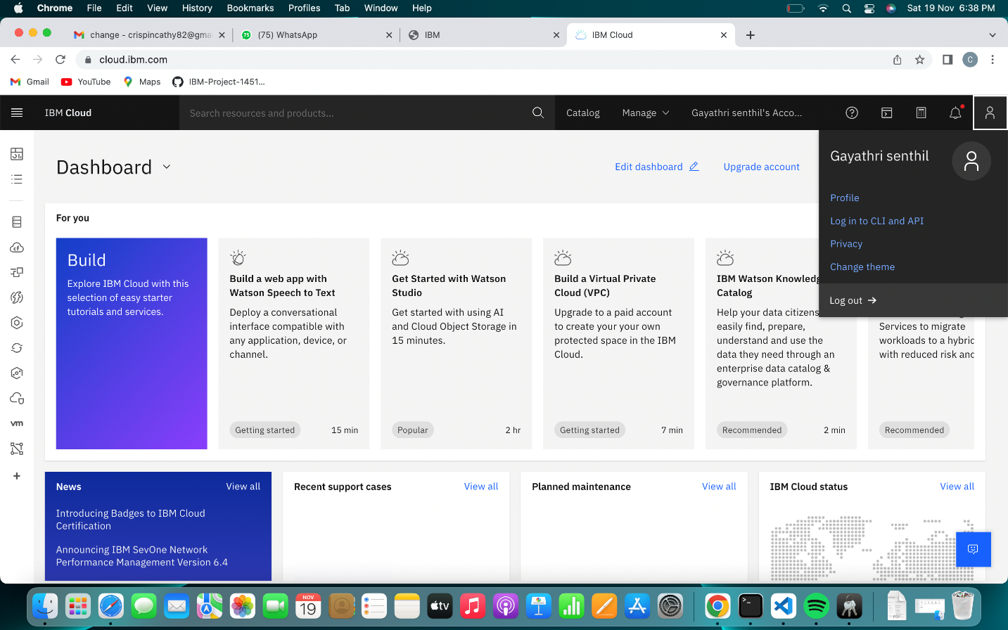

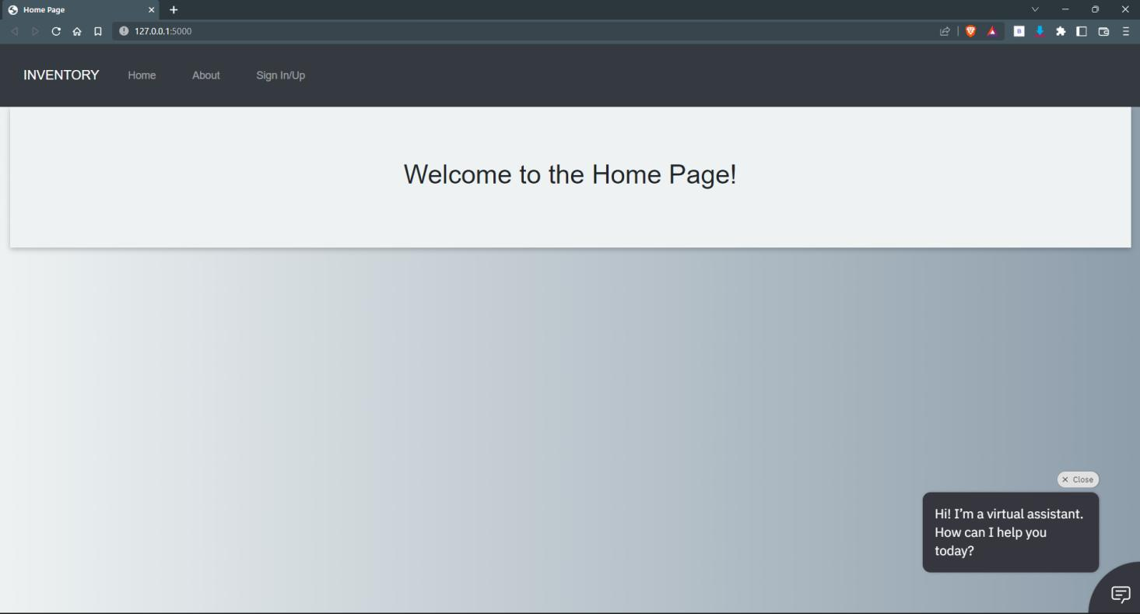

**Create IBM Cloud Account:**

**Docker Setup:**

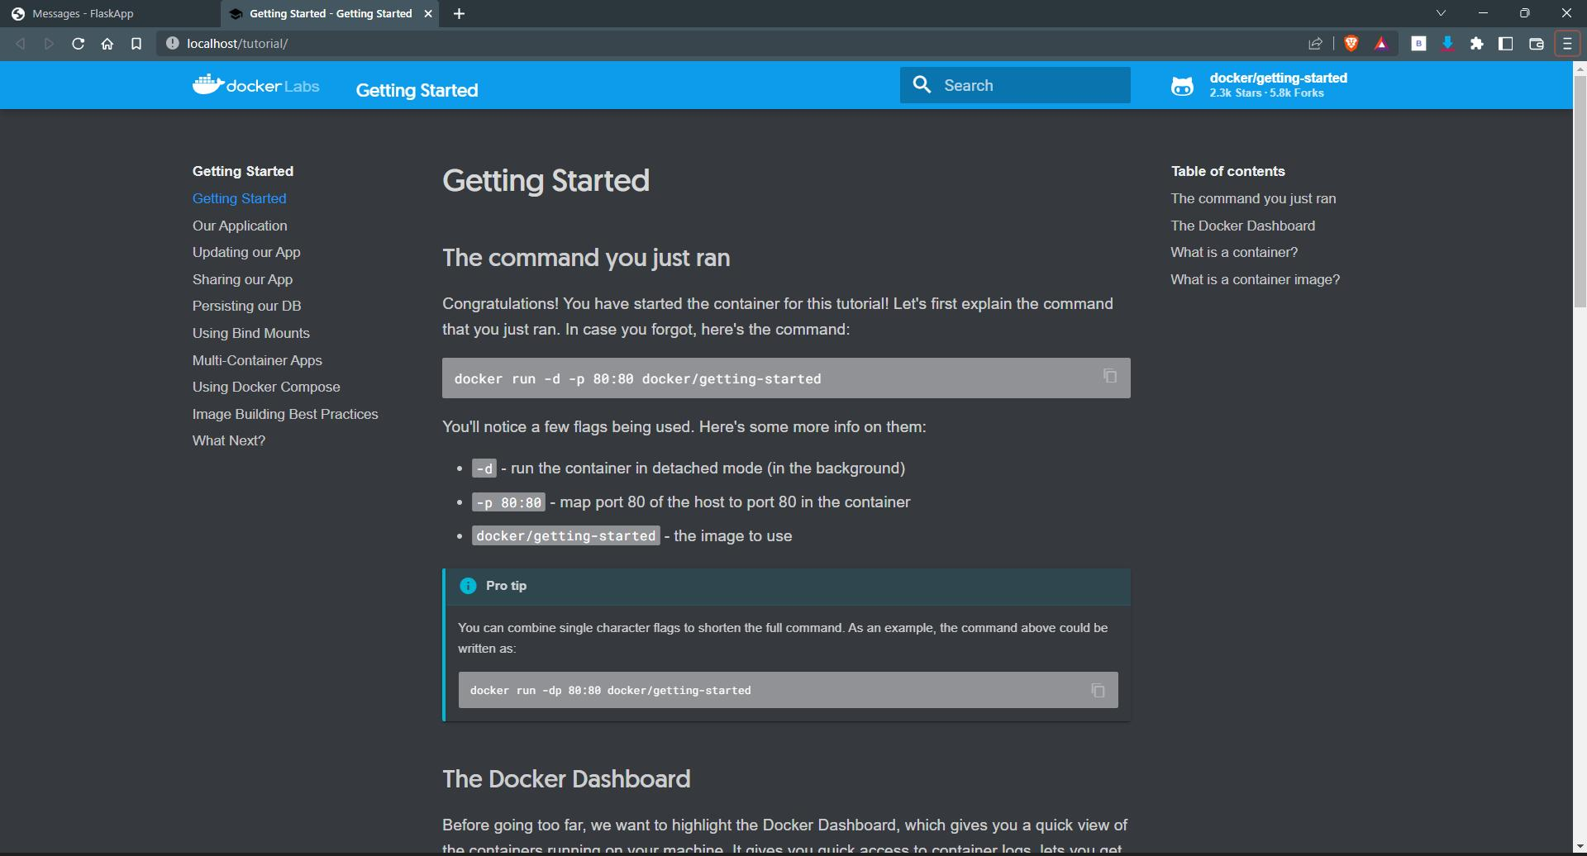

Create an account in SendGrid:

